Firstly
Create devops folder in Your Window’s Download
And Download 1_Whatisbigdata.zip from Drive and Paste only 1_Whatisbigdata.zip by extracting zip in this devops folder in Your Window’s Download

Go to virtual box>>> setting>> shared folder and press folder (green and blue color).

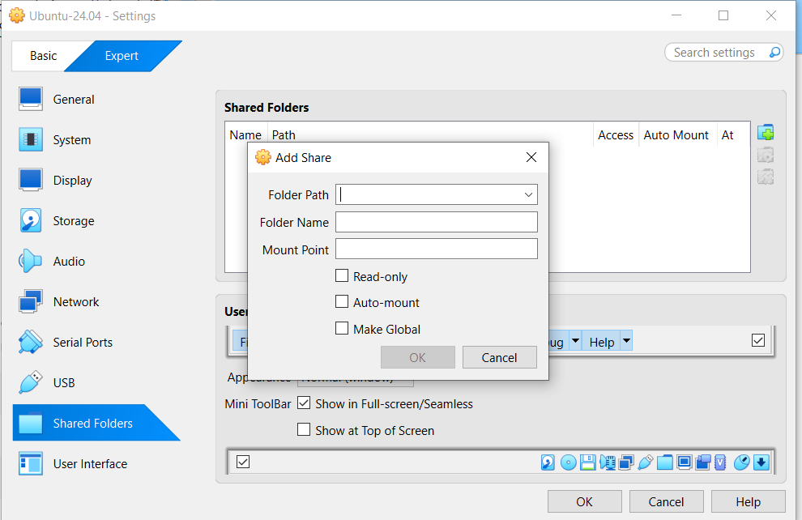

In folder path, choose other and choose C:\Users\...Downloads\devops

Tick all except read only, don’t make tick read only. And press ok

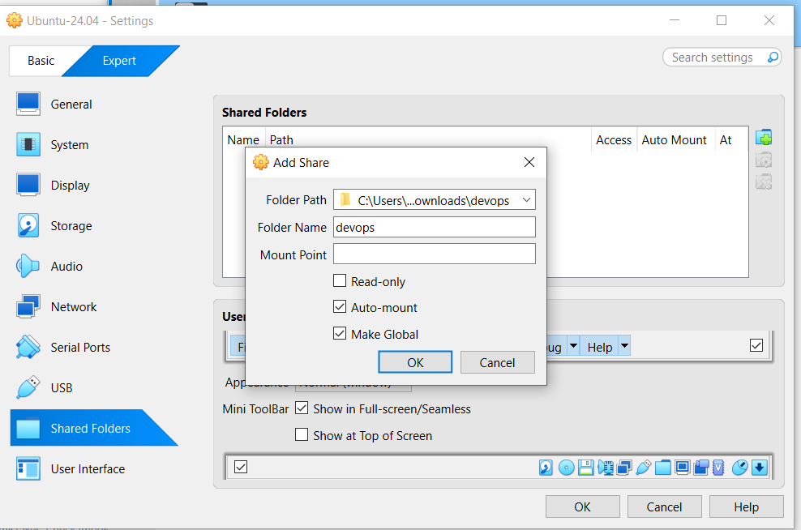

Go to ubuntu terminal>>>>
sudo apt update
sudo apt install virtualbox-guest-utils virtualbox-guest-x11 -y
sudo reboot
Open terminal again>>>>
ls /media
VirtualBox Shared Folder Name ကို devops လို့သတ်မှတ်ခဲ့ရင်—

sf_devops ပေါ်လာသင့်ပါတယ်။
sudo ls -lh /media/sf_devops
sudo apt update
sudo apt install default-jdk python3-venv -y
java -version

python3 -m venv ~/pyspark-env
source ~/pyspark-env/bin/activate
Prompt အစမှာ ဒီလိုပေါ်ရပါမယ်—

(pyspark-env)
python -m pip install --upgrade pip
အခု (pyspark-env) ပေါ်နေတဲ့ Terminal မှာ PySpark နဲ့ Jupyter ကို install လုပ်ပါ—

pip install pyspark notebook ipykernel
ပြီးသွားရင် kernel register လုပ်ပါ—

python -m ipykernel install --user --name pyspark-env --display-name "Python (PySpark)"
နောက်ဆုံး PySpark version စစ်ပါ—

python -c "import pyspark; print(pyspark.__version__)"

